EPI21 News Release
Presentation #12
Embargoed until 10 a.m. CT/ 11 a.m. ET, Thursday, May 20, 2021

Contact Information: Priya M. Freaney, M.D., may be reached at 270-304-7770 or priya.mehta@northwestern.edu (please do not publish contact information).

Session Assignment
02B - Cardiovascular Outcomes and Risk Prediction (Presentation #: 012 ; Speaking Time: 5/20/2021 11:47:00 AM - 5/20/2021 11:55:00 AM)

Title
Association Between Premature Menopause And Lifetime Risk Of Coronary Heart Disease: Lifetime Risk Pooling Project

Abstract Content
Introduction: Menopause before the age of 40 years is recognized as a risk enhancer for coronary heart disease (CHD) by the 2019 AHA/ACC Primary Prevention guidelines. Race-specific prevalence of premature menopause and its association with lifetime risk of CHD morbidity and mortality have not been well described in Black and White women, and could inform risk stratification and intensity of prevention efforts. Hypothesis: We hypothesized that Black and White women who experience premature menopause (<40 years) will have similarly elevated lifetime burden of CHD compared with women of the same race who do not have premature menopause. Methods: We pooled individual-level data from Black and White postmenopausal women aged 55-69 years from 6 US population-based cohorts. We included women without CHD at baseline and excluded women who reported surgical menopause. We defined premature menopause as age <40 years. We performed (1) modified Kaplan Meier analysis and (2) competing Cox models to estimate joint cumulative risk for CHD or non-cardiovascular death adjusted for age, smoking, education, obesity, hypertension, and diabetes. Results: Of the 3522 Black women and 6514 White women, mean ages were 61.2 ± 4.3 and 60.0 ± 4.4 years, respectively. Premature menopause (<40 years) occurred more commonly in Black (15.5%) compared with White (4.8%) women. Lifetime risk of CHD was higher in Black and White women with premature menopause (Figure). Hazard ratios adjusted for risk factors and accounting for competing risk of death were higher in Black (1.41 [1.04, 1.90]) and White (1.39 [1.03, 1.87]) women with premature menopause compared those Black and White women without premature menopause, respectively. Conclusions:Black women are three times more likely to experience premature natural menopause (<40 years) than White women. Premature menopause is independently associated with 40% higher risk of CHD in both Black and White women and should be assessed as a risk-enhancing feature in clinical prevention decisions.
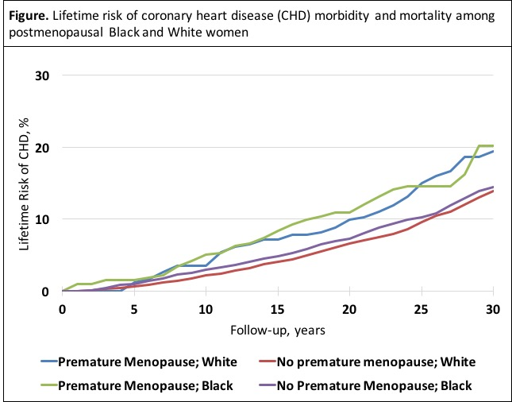

Author Block
Priya M Freaney, Hongyan Ning, Mercedes R Carnethon, John T Wilkins, Norrina B Allen, Donald M Lloyd-Jones, NORTHWESTERN UNIVERSITY, Chicago, IL; Sadiya Khan, Chicago, IL

