August 23, 2022
Join us in welcoming and celebrating the lives and stories of our Greater Washington and Greater Baltimore Kids Heart Challenge Ambassadors!
Link here for the full news release
In preparation for the 2022-2023 academic year, the AHA Greater Washington and Greater Baltimore regions proudly introduces four local Youth Heart Ambassadors based in Montgomery, St. Mary’s and Carroll counties. Ambassadors are the heart of our in-school programs, sharing their stories and elevating their voices to inspire their peers to live healthier lives.
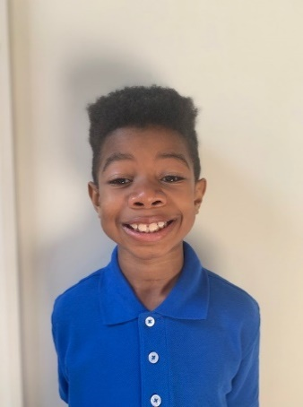
Meet Jadon
Grade 4 | Montgomery County Public Schools
Jadon was born with Tetralogy of Fallot, a common congenital heart defect, and at 6 months old, he underwent open-heart surgery to save his life. Today, he is an active and healthy fourth-grader who plays soccer, takes karate classes, and enjoys spending time with his family and pet snail Samson.
“I want people – especially kids – to learn about the heart and ways to keep it healthy. I want to tell kids what happened to me to help anyone who may be going through what I went through,” Jadon shared about why he passionately supports the Kids Heart Challenge.
Photo copyright: The Jackson Family
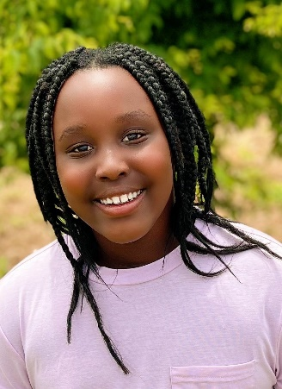
Meet Hope
Grade 5 | Montgomery County Public Schools
When Hope was born, doctors discovered her left artery was displaced. She had a heart murmur, which required strict monitoring for several years. An energetic 10-year-old, she is a cheerleader, basketball player and swimmer.
“I want to spread hope to other heart patients by supporting the American Heart Association,” Hope shared regarding her excitement to serve as a local Ambassador. Photo copyright: The Hakiza Family
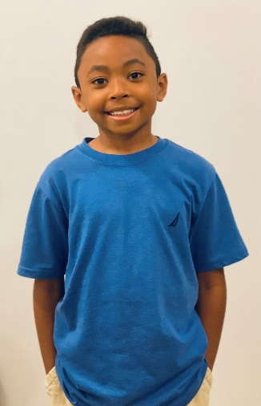
Meet Jaylin
Grade 3 | St. Mary’s County Public Schools
At the age of 2, Jaylin was diagnosed with Kawasaki disease (KD), which causes inflammation in the blood vessels and coronary arteries. Boys are 1.5 times more likely to get KD, and about 77% of all cases occur in children under the age of 5.
“His strength gave us strength,” his mother reflected on Jaylin’s time in the hospital receiving infusions and lifesaving treatment. Today, Jaylin is a healthy 8-year-old who enjoys playing outside, basketball and running.
“Now, I am better and am able to do anything,” Jaylin said. “I want to help people have healthy hearts. I like the Kids Heart Challenge and the American Heart Association because they help people.” Photo copyright The Hayden Family
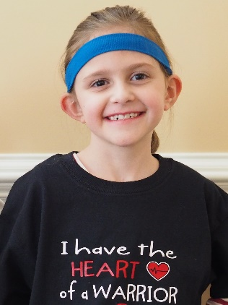
Meet Sophia
Grade 7 | Carroll County Public Schools
Sophia was born with a congenital heart defect called Tetralogy of Fallot with pulmonary atresia, which means there were five abnormalities in her heart. She was also born early, at 34 weeks, weighing just 3 pounds and 7 ounces. She had her first echocardiogram just hours into her life, the first of nearly a dozen heart catheterizations at 3 days old, and her first reconstructive heart surgery at 2-and-a-half months.
“Thanks to advances in cardiovascular research and technology that have been funded by the American Heart Association, I’m able to live a full and happy life, something that a few decades ago might not have been possible for someone who was born CHD like I was,” Sophia says.
“She’s an active 11-year-old who loves life,” her mother, Jennifer, says. “Her strength, her bravery makes me a very proud mom. She really is a heart hero to me.” Photo copyright: The Ferraro Family
For Media Inquiries:
Rachel Stevenson, Communications Director
rachel.stevenson@heart.org

